Overlapping Collinear Segments
# Source: AI Source: Provided by: [Data Path: Persons Table -> ID Column: 1, Name_En Column: Motasem Essam] -> From: [ChatGPT] on [7/25/2026]
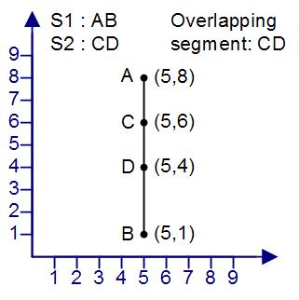
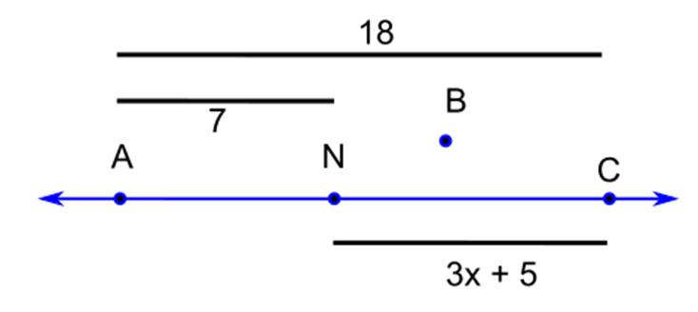
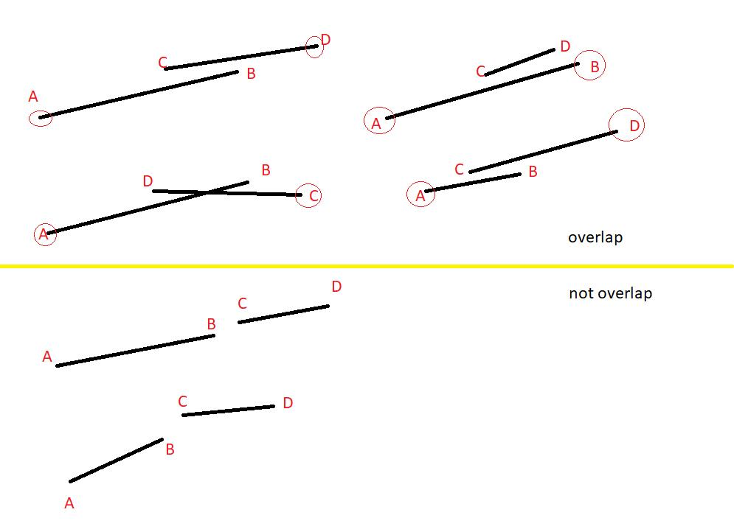

Definition
# Source: AI Source: Provided by: [Data Path: Persons Table -> ID Column: 1, Name_En Column: Motasem Essam] -> From: [ChatGPT] on [7/25/2026]
Overlapping Collinear Segments are two or more line segments that:
- Lie on the same supporting straight line.
- Share a positive-length portion of that line.
- Are not necessarily completely identical.
For two segments $\overset{‾}{AB}$and $\overset{‾}{CD}$, they are overlapping collinear segments when there is a line $l$such that
$$\overset{‾}{AB}⊆l$$
and
$$\overset{‾}{CD}⊆l$$
and their intersection contains more than one point:
$$\overset{‾}{AB}∩\overset{‾}{CD}$$
is itself a segment of positive length.
Simple Example
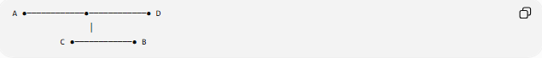
A ●────────────●────────────● D
│
C ●────────────● B
More precisely, if the order is
A ●────────● C────────● B────────● D
then:
$$\overset{‾}{AB}∩\overset{‾}{CD}=\overset{‾}{CB}$$
So $\overset{‾}{AB}$and $\overset{‾}{CD}$overlap along $\overset{‾}{CB}$.

Purpose
# Source: AI Source: Provided by: [Data Path: Persons Table -> ID Column: 1, Name_En Column: Motasem Essam] -> From: [ChatGPT] on [7/25/2026]
Overlapping collinear segments are useful for describing the positional relationship between segments that occupy some of the same portion of a straight line.
They are important in:
- Segment relationships
- Line and interval analysis
- Coordinate geometry
- One-dimensional geometry
- Computational geometry
- Geometric modeling
- Construction and engineering drawings

Fundamental Conditions
# Source: AI Source: Provided by: [Data Path: Persons Table -> ID Column: 1, Name_En Column: Motasem Essam] -> From: [ChatGPT] on [7/25/2026]
For two segments to be overlapping and collinear, all of the following must hold:
1. Same Supporting Line
Both segments must lie on one straight line:
$$A,B,C,D∈l$$
2. Common Points
They must have at least one common point:
$$\overset{‾}{AB}∩\overset{‾}{CD}≠∅$$
3. Positive-Length Intersection
For genuine overlap, their common portion must have positive length:
$$length⁡\left(\overset{‾}{AB}∩\overset{‾}{CD}\right)>0$$
This distinguishes overlapping segments from merely touching segments.

Interval Representation
# Source: AI Source: Provided by: [Data Path: Persons Table -> ID Column: 1, Name_En Column: Motasem Essam] -> From: [ChatGPT] on [7/25/2026]
A particularly simple way to represent collinear segments is as intervals on a number line.
Suppose:
$$\overset{‾}{AB}=\left[a , b\right]$$
and
$$\overset{‾}{CD}=\left[c , d\right]$$
where:
$$a<b, c<d$$
The segments overlap when:
$$\boxed{max⁡\left(a , c\right)<min⁡\left(b , d\right)}$$
The overlapping portion is:
$$\boxed{\left[max , ⁡\left(a , c\right)min⁡\left(b , d\right)\right]}$$

Example 1: Partial Overlap
# Source: AI Source: Provided by: [Data Path: Persons Table -> ID Column: 1, Name_En Column: Motasem Essam] -> From: [ChatGPT] on [7/25/2026]
Consider:
$$\overset{‾}{AB}=\left[1 , 8\right]$$
and
$$\overset{‾}{CD}=\left[5 , 12\right]$$
Their common portion is:
$$\left[5 , 8\right]$$
Therefore:
$$\overset{‾}{AB}∩\overset{‾}{CD}=\left[5 , 8\right]$$
and the overlap length is:
$$8-5=3$$
So the segments are overlapping collinear segments.

Example 2: One Segment Inside Another
# Source: AI Source: Provided by: [Data Path: Persons Table -> ID Column: 1, Name_En Column: Motasem Essam] -> From: [ChatGPT] on [7/25/2026]
Consider:
$$\overset{‾}{AB}=\left[1 , 10\right]$$
and
$$\overset{‾}{CD}=\left[4 , 7\right]$$
The second segment lies completely inside the first:
A ●────────────────────────● B
C ●──────● D
Their intersection is:
$$\overset{‾}{CD}$$
This is still an overlapping collinear relationship.
The smaller segment is completely contained within the larger segment.

Example 3: Coordinate Geometry
# Source: AI Source: Provided by: [Data Path: Persons Table -> ID Column: 1, Name_En Column: Motasem Essam] -> From: [ChatGPT] on [7/25/2026]
Let:
$$A=\left(1 , 4\right), B=\left(9 , 4\right)$$
and
$$C=\left(5 , 4\right), D=\left(13 , 4\right)$$
All four points have the same $y$-coordinate:
$$y=4$$
Therefore, both segments lie on the same supporting line:
$$y=4$$
Their intervals along the $x$-axis are:
$$\left[1 , 9\right]$$
and
$$\left[5 , 13\right]$$
Their intersection is:
$$\left[5 , 9\right]$$
Therefore:
$$\overset{‾}{AB}∩\overset{‾}{CD}=\overset{‾}{BC}$$
and the overlap length is:
$$9-5=4$$

Types of Overlap
# Source: AI Source: Provided by: [Data Path: Persons Table -> ID Column: 1, Name_En Column: Motasem Essam] -> From: [ChatGPT] on [7/25/2026]
Overlapping collinear segments can occur in several configurations.

1. Partial Overlap
# Source: AI Source: Provided by: [Data Path: Persons Table -> ID Column: 1, Name_En Column: Motasem Essam] -> From: [ChatGPT] on [7/25/2026]
Each segment extends beyond the common portion.
A ●────────●────────● D
C────────B
The segments share only part of their lengths.

2. Containment Overlap
# Source: AI Source: Provided by: [Data Path: Persons Table -> ID Column: 1, Name_En Column: Motasem Essam] -> From: [ChatGPT] on [7/25/2026]
One segment lies entirely inside the other.
A ●────────────────● B
C ●────● D
The entire smaller segment is shared.

3. Endpoint-Included Overlap
# Source: AI Source: Provided by: [Data Path: Persons Table -> ID Column: 1, Name_En Column: Motasem Essam] -> From: [ChatGPT] on [7/25/2026]
One endpoint of one segment lies inside the other segment while the segments share a positive-length portion.
For example:
$$A<C<B<D$$
The overlap is:
$$\overset{‾}{CB}$$

Overlap Length
# Source: AI Source: Provided by: [Data Path: Persons Table -> ID Column: 1, Name_En Column: Motasem Essam] -> From: [ChatGPT] on [7/25/2026]
For two intervals
$$\left[a , b\right]$$
and
$$\left[c , d\right]$$
the overlap length is:
$$\boxed{L_{\text{overlap}}=min⁡\left(b , d\right)-max⁡\left(a , c\right)}$$
provided that:
$$min⁡\left(b , d\right)>max⁡\left(a , c\right)$$
If the result is zero, the segments merely touch.
If the result is negative, they are separated.

Comparison with Other Collinear Segment Relationships
# Source: AI Source: Provided by: [Data Path: Persons Table -> ID Column: 1, Name_En Column: Motasem Essam] -> From: [ChatGPT] on [7/25/2026]
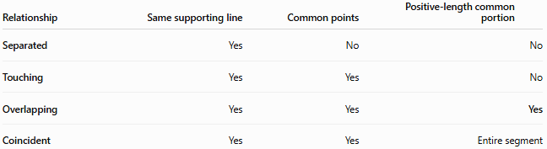
Relationship | Same supporting line | Common points | Positive-length common portion
Separated | Yes | No | No
Touching | Yes | Yes | No
Overlapping | Yes | Yes | Yes
Coincident | Yes | Yes | Entire segment
The key distinction is the size of the intersection.
$$\begin{matrix}\text{Separated:} & A∩B=∅ \\ \text{Touching:} & length⁡\left(A∩B\right)=0 \\ \text{Overlapping:} & length⁡\left(A∩B\right)>0 \\ \text{Coincident:} & A=B\end{matrix}$$

Overlapping vs. Coincident
# Source: AI Source: Provided by: [Data Path: Persons Table -> ID Column: 1, Name_En Column: Motasem Essam] -> From: [ChatGPT] on [7/25/2026]
These two concepts are particularly important to distinguish.
Overlapping
Only part of the segments is necessarily common.
Example:
$$\left[1 , 8\right]∩\left[5 , 12\right]=\left[5 , 8\right]$$
The segments are different, but share part of their lengths.
Coincident
The two segments occupy exactly the same set of points.
Example:
$$\left[1 , 8\right]∩\left[1 , 8\right]=\left[1 , 8\right]$$
Thus:
Every pair of coincident segments is overlapping in the broad set-theoretic sense, but coincident segments are normally classified separately because they have complete rather than partial overlap.

Mathematical Characterization
# Source: AI Source: Provided by: [Data Path: Persons Table -> ID Column: 1, Name_En Column: Motasem Essam] -> From: [ChatGPT] on [7/25/2026]
For two collinear segments $S_{1}$and $S_{2}$:
$$S_{1}⊆l \\ S_{2}⊆l$$
and
$$S_{1}∩S_{2}≠∅$$
with
$$\boxed{length⁡\left(S_{1}∩S_{2}\right)>0}$$
For interval representations:
$$S_{1}=\left[a , b\right], S_{2}=\left[c , d\right]$$
with:
$$\boxed{max⁡\left(a , c\right)<min⁡\left(b , d\right)}$$

Important Properties
# Source: AI Source: Provided by: [Data Path: Persons Table -> ID Column: 1, Name_En Column: Motasem Essam] -> From: [ChatGPT] on [7/25/2026]
- Both segments lie on the same straight line.
- They share infinitely many points when the overlap has positive length.
- Their intersection is itself a line segment.
- The overlap can be partial or can involve complete containment of one segment inside the other.
- Overlap is symmetric:
$$S_{1}\text{ overlaps }S_{2} ⟺ S_{2}\text{ overlaps }S_{1}$$
- Two overlapping segments are automatically collinear.
- Overlapping segments have zero minimum separation distance because they share points.
- Their intersection has positive length.
- Overlap does not mean that the two segments are equal.
- Coincident segments are a special complete-overlap case and are usually classified separately.

Real-World Applications
# Source: AI Source: Provided by: [Data Path: Persons Table -> ID Column: 1, Name_En Column: Motasem Essam] -> From: [ChatGPT] on [7/25/2026]
Roads and Paths
Two mapped road sections may cover the same portion of a straight road.
Engineering
Structural members or construction boundaries can partially occupy the same linear region.
CAD
Computer-aided design systems need to detect overlapping edges to avoid duplicate geometry.
Maps
Two linear geographic features may represent the same portion of a boundary or route.
Computational Geometry
Algorithms frequently need to determine whether two line segments overlap, touch, or are separated.

Key Points
# Source: AI Source: Provided by: [Data Path: Persons Table -> ID Column: 1, Name_En Column: Motasem Essam] -> From: [ChatGPT] on [7/25/2026]
- Overlapping Collinear Segments lie on the same straight line.
- They share a positive-length portion.
- Their intersection is a segment:
$$S_{1}∩S_{2}=S_{\text{overlap}}$$
- For intervals:
$$\boxed{max⁡\left(a , c\right)<min⁡\left(b , d\right)}$$
indicates positive-length overlap.
- Touching has zero-length intersection.
- Separated segments have no intersection.
- Coincident segments share their entire extent.

Conclusion
# Source: AI Source: Provided by: [Data Path: Persons Table -> ID Column: 1, Name_En Column: Motasem Essam] -> From: [ChatGPT] on [7/25/2026]
Overlapping Collinear Segments are collinear line segments that share a portion of positive length. They occupy some of the same part of a common straight line while remaining distinct segments. This relationship is fundamental for distinguishing partial overlap, containment, touching, separation, and coincidence among line segments.

